**Node.JS and NPM**

* Based on the Javascript runtime built on chrome V8 javascript engine
* Uses an event-driven, non-blocking I/O model
  + Makes it lightweight and efficient
* Node architecture

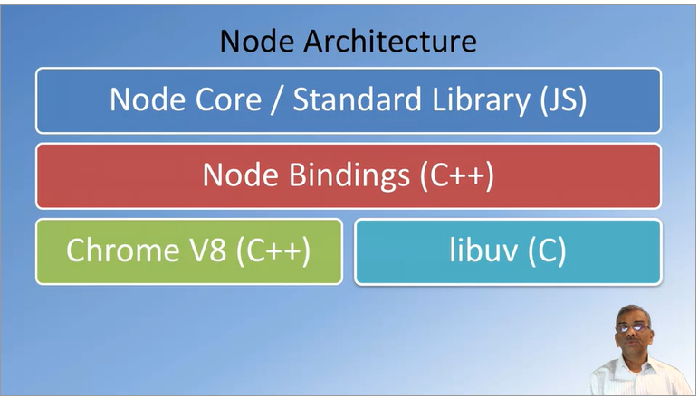

* Node.JS use cases
  + Utilities written in javascript for web development
    - Bower, grunt, gulp, yeoman, etc.
  + Server-side development
    - Web server, business logic, database access
    - All of this is implemented in javascript
* Node package manager
  + NPM: manages ecosystem of node modules/packages
  + A package contains
    - JS files
    - package.json (manifest)